GRANDSLAM ENTERTAINMENT, LLC
3351 CR 780 Jonesboro, AR 72401
2012 PRODUCT RENTAL INVENTORY

870-926-8640 Colby
870-926-9092 Bryan
870-219-8265 Jason

Like us on Facebook to receive special discounts:
www.Facebook.com/GrandslamEntertainment

Or visit our website:
http://GrandslamEntertainMe.Ipage.com

Email for more information:
GrandslamRentals@gmail.com

The above links are active if viewing on the internet, click to link to our Facebook page, Our Website, or to Email us!

Product Name | Description | Price per 4 Hours | Picture | Additional Info
Daisy Dino Ball Pit | Daisy Dino Ball Pit 4 Hour Rental | $75.00 | 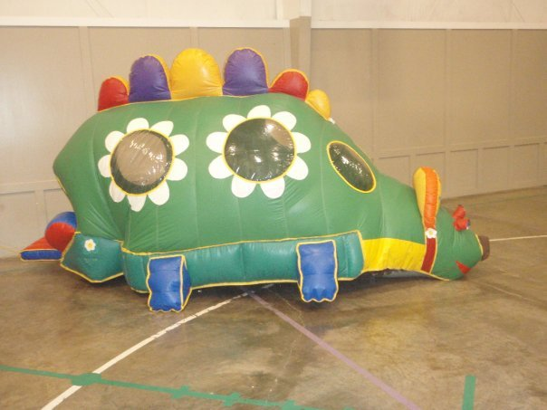 | Ideal as an additional unit for toddlers if older children will be present, or as a single unit for small childrens parties.
Mini Jump w Ball Pit | Mini Jump w Ball Pit 4 Hour Rental | $75.00 | 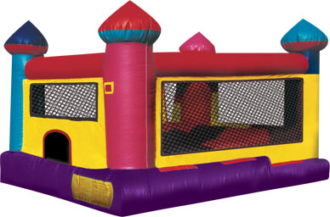 | Great for small parties of 4 to 6 children or as an additional unit for smaller children at parties with toddlers and older children.
Mini Allstar Basketball Shooot | Mini Allstar Basketball Shoot 4 Hour Rental | $75.00 | 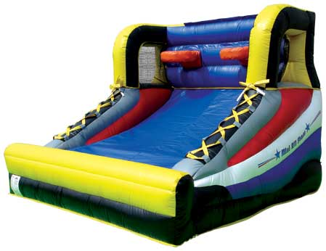 | Great for all age’s of children or as an additional unit with parties of 10 or more children
Castle Bounce | Castle Bounce House 4 Hour Rental | $100.00 | 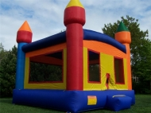 | Great for children of all ages with parties of 6 to 10 attendees.

Product Name | Description | Price per 4 Hours | Picture | Additional Info
Fire Truck Bouncer | Fire Truck Bouncer 4 Hour Rental | $125.00 | 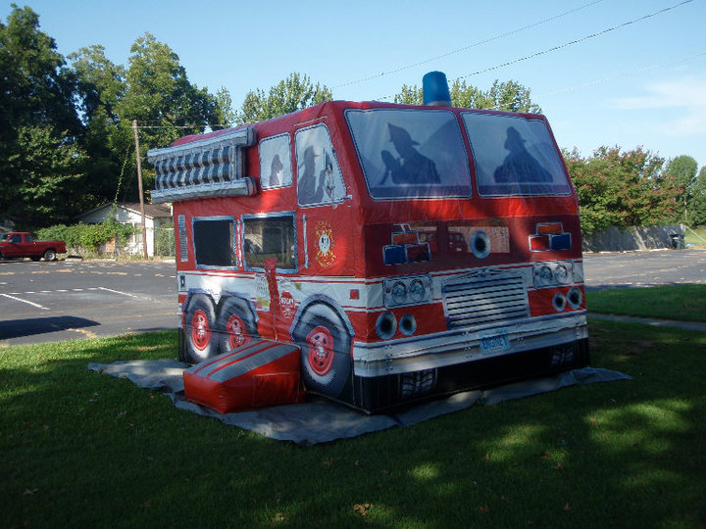 | Great for children up to 12 years of age for parties of 6 to 10 attendees.
Monster Truck Bouncer | Monster Truck Bouncer 4 Hour Rental | $125.00 | 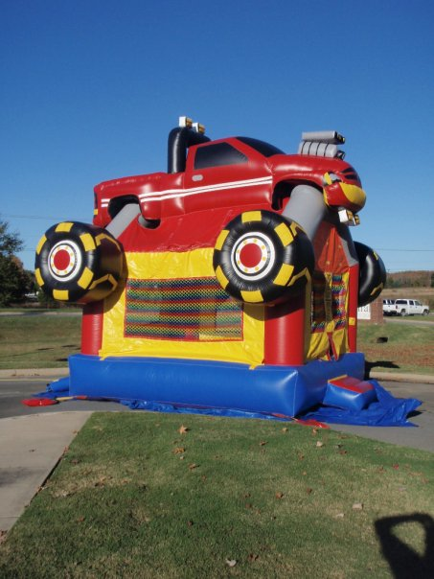 | Great for children up to 12 years of age for parties of 6 to 10 attendees.
Dual Slide Combo | Dual Slide Combo 4 Hour Rental | $150.00 | 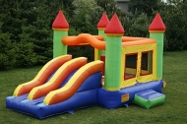 | Great for children up to 12 years of age for parties of 6 to 10 attendees.

Product Name | Description | Price per 4 Hours | Picture | Additional Info
Module Bouncer w Choice of Panel | Module Bouncer w Choice of Panel 4 Hour Rental | $150.00 | 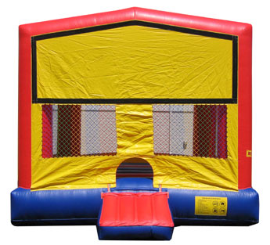 | Panel Choice: Batman, Dark Knight, Tinkerbell, Baseball, Dora, Thomas Train, Princess, Spiderman, Mickey & Friends, Spongebob, Noah’s Ark, Happy Birthday,Toy Story, Jungle Fun, Transformers
Jousting Arena | Jousting Arena 4 Hour Rental | $150.00 | 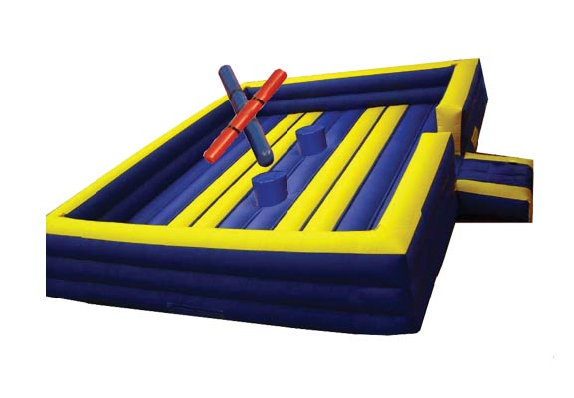 | Great for all ages, limit of 2 persons at a time in the Joust Arena!
Boxing Ring | Boxing Ring 4 Hour Rental | $150.00 | 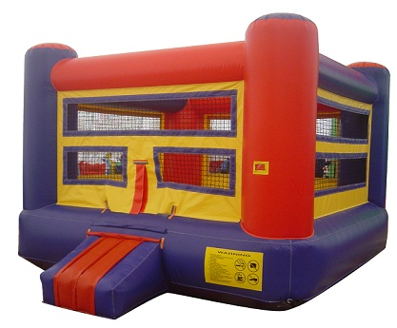 | Great for all ages, limit of 4 persons at a time in the Boxing Arena!
Dodgeball Arena | Dodgeball Arena 4 Hour Rental | $150.00 | 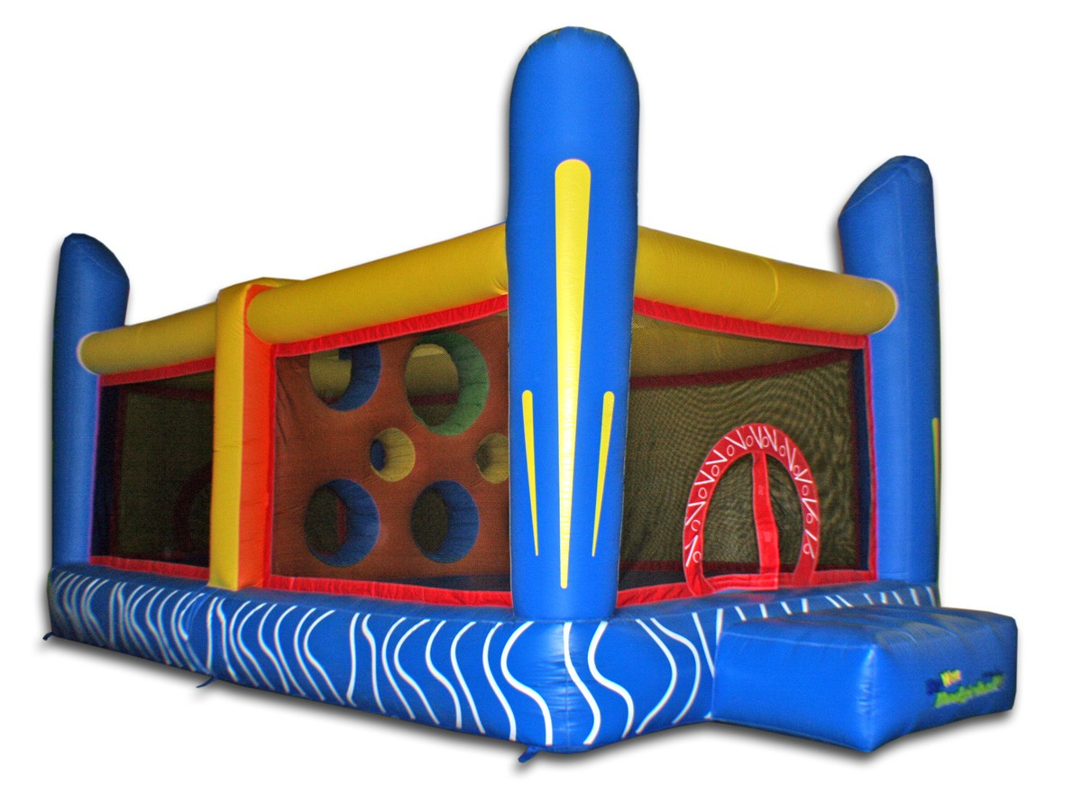 | Great for all ages and as an additional unit to large parties.

Product Name | Description | Price per 4 Hours | Picture | Additional Info
Jungle Combo | Jungle Combo 4 Hour Rental | $175.00 | 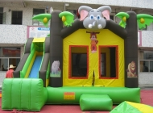 | Great for all ages and parties of 6 to 10 attendees.
Module 2 in 1 wet/dry Combo | Module 2 in 1 wet/dry Combo 4 Hour Rental | $175.00  Dry Use | 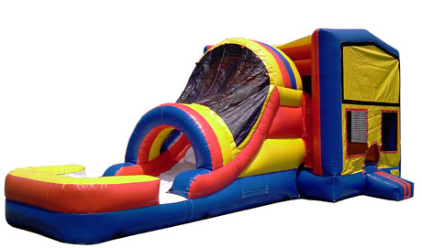 | Panel Choice: Batman, Dark Knight, Tinkerbell, Baseball, Dora, Thomas Train, Princess, Spiderman, Mickey & Friends, Spongebob, Noah’s Ark, Happy Birthday,Toy Story, Jungle Fun, Transformers
It’s a Girl Thing | It’s a Girl Thing 4 Hour Rental | $200.00 | 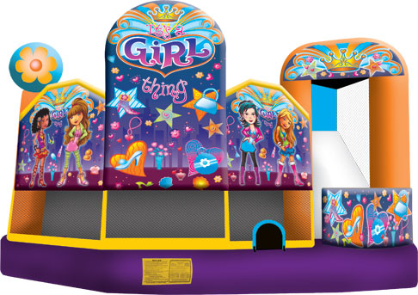 | Great for that Special Girls Birthday Party!
Module 5 in 1 | Module 5 in 1 4 Hour Rental | $200.00 | 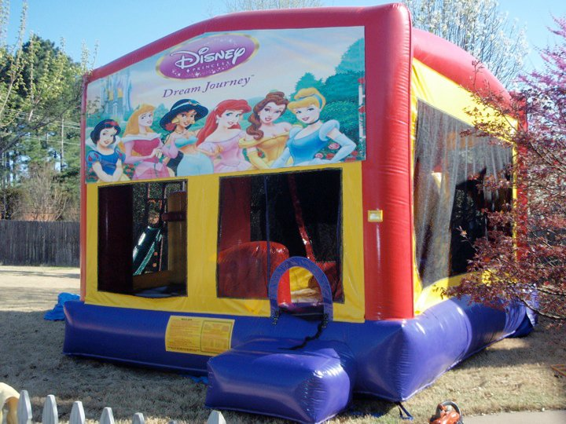 | Panel Choice: Batman, Dark Knight, Tinkerbell, Baseball, Dora, Thomas Train, Princess, Spiderman, Mickey & Friends, Spongebob, Noah’s Ark, Happy Birthday,Toy Story, Jungle Fun, Transformers

Module 2 in 1 wet/dry Combo | Module 2 in 1 wet/dry Combo 4 Hour Rental | $200.00  Wet Use | 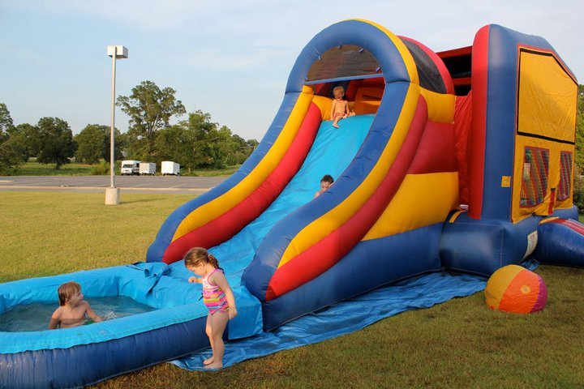 | Panel Choice: Batman, Dark Knight, Tinkerbell, Baseball, Dora, Thomas Train, Princess, Spiderman, Mickey & Friends, Spongebob, Noah’s Ark, Happy Birthday,Toy Story, Jungle Fun, Transformers
12’ Dolphin Wave WaterSlide | 12’ Dolphin Wave WaterSlide  4 Hour Rental | $250.00 | 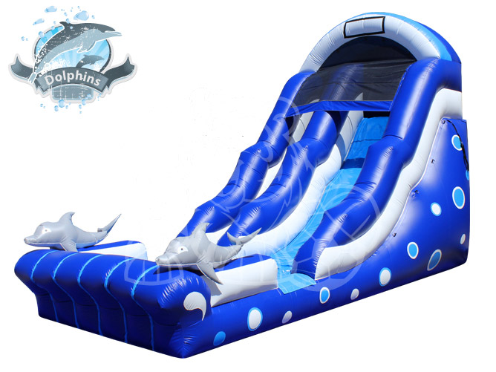 | Great for all ages and parties, Festivals and Large Events.
14’ Water Slide w pool | 14’ Water Slide 4 Hour Rental | $300.00 | 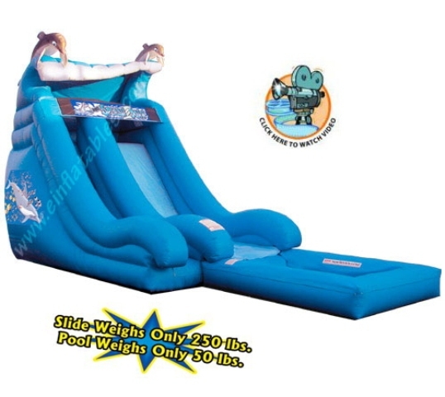 | Great for all ages and parties, Festivals and Large Events.
18’ Double Slide | 18’ Double Slide 4 Hour Rental | $350.00 | 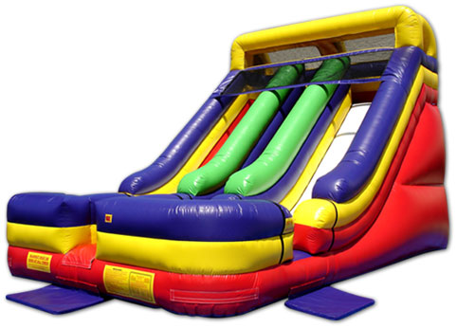 | Great for all ages and parties, Festivals and Large Events.

18’ Fire Truck Slide | 18’ Fire Truck Slide 4 Hour Rental | $350.00 | 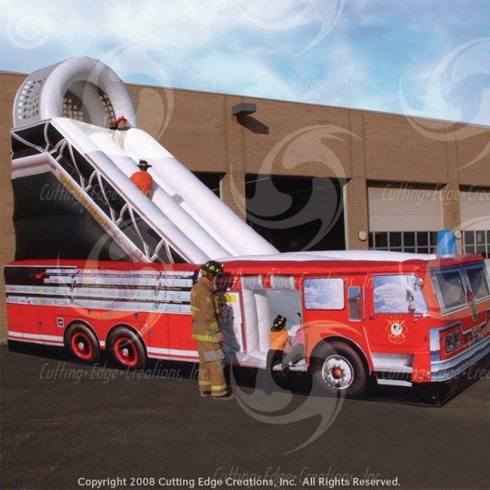 | Great for all ages and parties, Festivals and Large Events.
65’ Obstacle Course | 65’ Obstacle Course 4 Hour Rental | $400.00  $200.00 for obstacle half $350.00 for slide half | 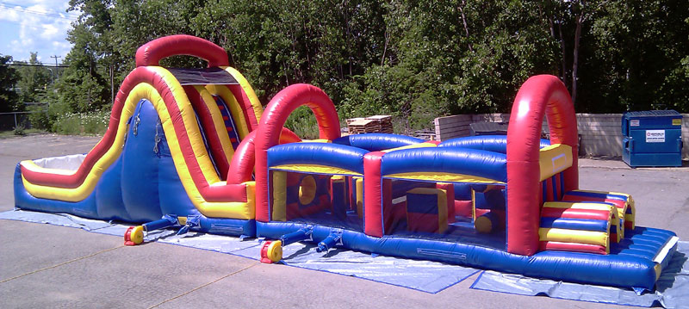 | Great for all ages and parties, Festivals and Large Events.

